Assignment –7

1. **Write a query that counts all orders for October 3.**

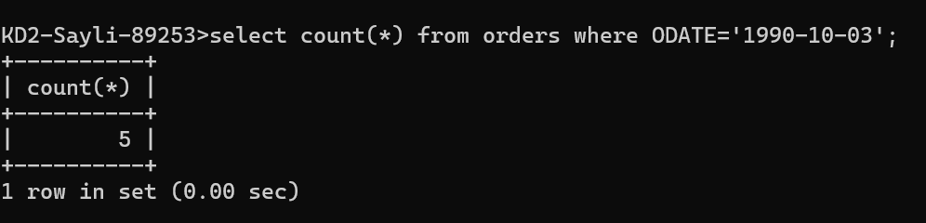

1. **Write a query that counts the number of different non-NULL city values in the Customers table.**

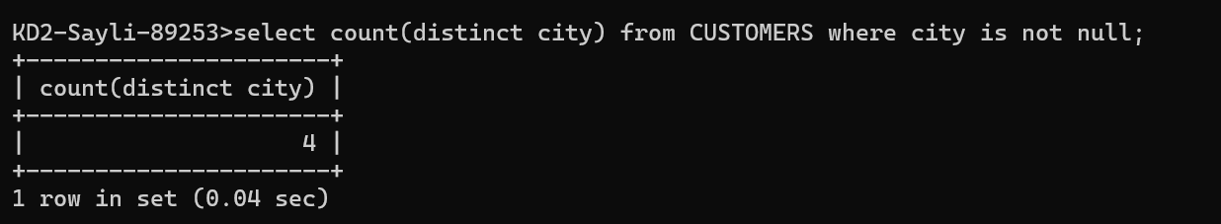

1. **Write a query that selects each customer’s smallest order.**

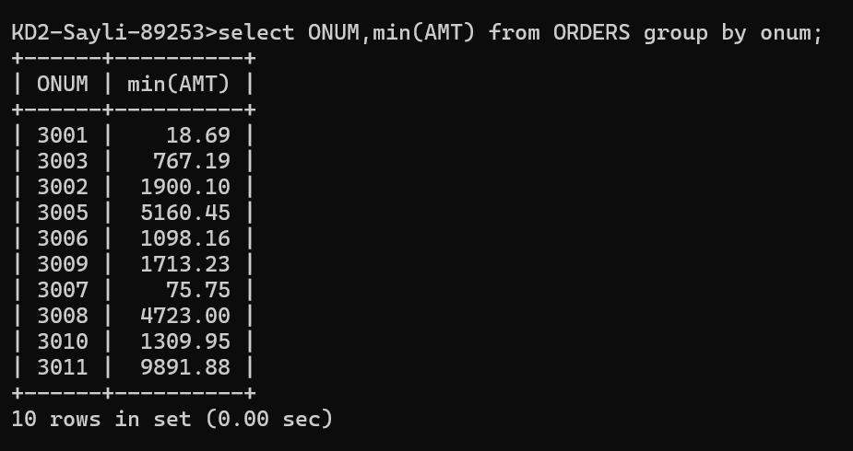

1. **) Write a query that selects the first customer, in alphabetical order, whose name begins with G.**

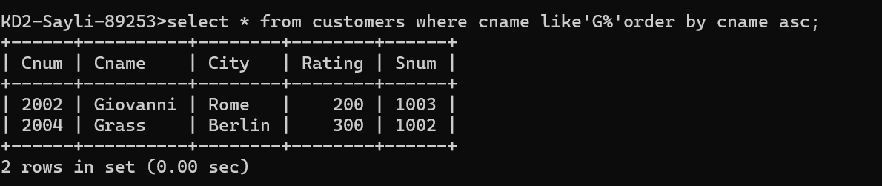

1. **Write a query that selects the highest rating in each city.**

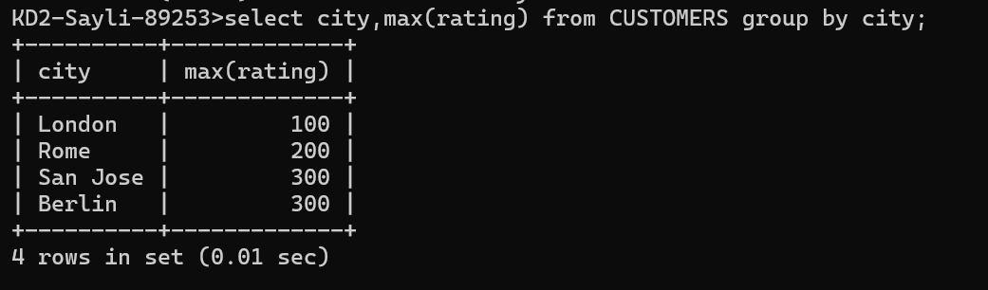

**6) Write a query that counts the number of salespeople registering orders for each day. (If a salesperson has more than one order on a given day, he or she should be counted once.**

